22nd May 2026

Dear Parent/Carer,
Class of 2026 - End of Year Arrangements

As you are no doubt aware, Y11 are well into their Final GCSE examinations. I wanted to take this opportunity to congratulate them on their attitude and effort throughout what is undoubtedly a period of great pressure. I wanted to write to inform you of the end of year arrangements for Y11; below you will find important information and key dates pertaining to the end of the Summer Exams:

Event | Date | Time
May half-term Intervention | 26th – 30th May 2026 | Details overleaf
Y11 Study Leave commences | Friday 12th June 2026 | 12:30
Y11 Leavers Assembly | Friday 19th June 2026 | 08:30-10:00
Y11 Prom | Friday 3rd July 2026 | 18:00 (arrive StC)  18:45 (depart StC)  22:45 (return to StC)

School attendance remains compulsory up to and including Friday 12th June until 12:30pm. After the Chemistry exam, students will either go to Hospitality and Catering revision or Physics revision for the duration of period 3. Students that are not required for the Hospitality and Catering exam in the afternoon have the option to leave the site at lunchtime. Otherwise, they will be supervised for the remainder of the day to complete private study.

After this date, students will only be required in school for these remaining exams:

Date | AM | PM
Monday 15th June | Physics Paper 2  1 hr 15 mins (F)/1 hr 45 mins (H) | Retail Business 1 hr 30 mins  Further maths 2 hrs
Tuesday 16th June | Spanish reading  1 hr 15 mins (F)/1 hr 20 mins (H)
Wednesday 17th June | Spanish writing  1 hr 15 mins (F)/1 hr 20 mins (H)

There will also be revision sessions on Monday 15th June period 3 (11:30-12:30) for those students taking retail business and further maths. Spanish revision will also be available from 8am on both Tuesday 16th and Wednesday 17th June before the exams.

Students will still be required to wear their full school uniform for all remaining exams and revision sessions.

If you wish to discuss the contents of this letter please do not hesitate to contact me. I look forward to celebrating this important time in your son/daughter’s life and wish them continued success with their remaining exams.

Yours Sincerely,

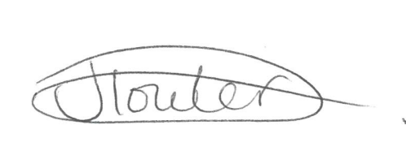

Miss J Towler
Head of Year 11

 | May half-term interventions
 | Tues 26th May | Weds 27th May | Thurs 28th May | Fri 29th May
AM  (9am-12pm) | Science  (Chem & Phys)  9-11am | History | PE | English  (aiming for G4/5)
PM  (12pm-3pm) | English  (aiming for G7+) | Music | Maths

Please remember:
- To arrive via main school entrance
- To sign in and out in main reception
- To bring a packed lunch or money to purchase lunch locally (canteen not available)
- You are not required to wear school uniform
- To arrive promptly for sessions and remain with supervising when on site
- To bring equipment required to participate

