YEAR 10
REVISION PACK
Contents
Revision tips……………………………3
Revision techniques……………….…4
Topics to Revise……………………..5-7
Revision Timetable…………………8-10
Exam Timetable……………………....11
After School revision………………....12

Revision Tips
- Start early- give yourself the most time possible to revise.
- Plan your revision- use the revision timetable below.
- Get the basics right- make sure you are eating healthily, drinking plenty of water, exercising and getting a good night's sleep
- Remove distractions- place your phone in a draw or another room.
- Short sessions- keep sessions to 25 minutes, followed by 5 minute breaks.
- Break topics down into bite-size chunks.
- Repetition- the more times you revise a topic, the more likely you are to remember it.

Revision Techniques
Flash cards & Spaced learning
- Use your notes or your textbook to identify key concepts in the material. On one side of a flashcard, write the keyword. On the back of the flashcard, write the definition.
- Complete retrieval practice by reading the key word on one side, and trying to recall the definition.

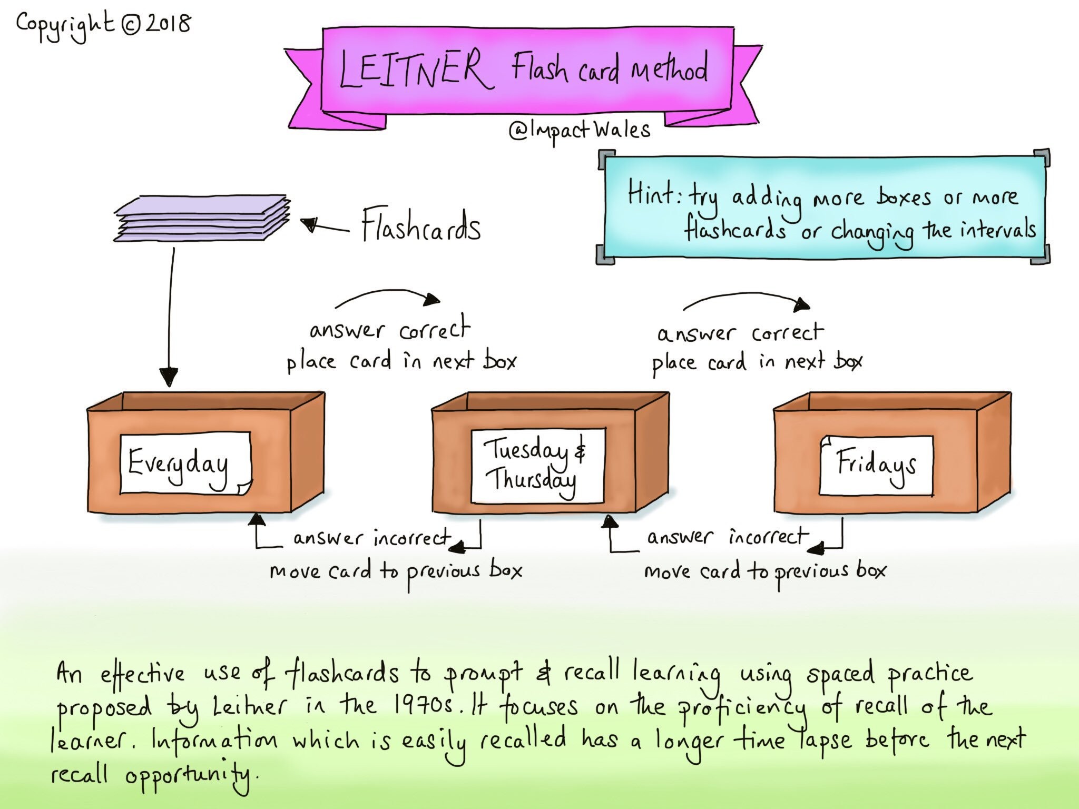

How to make flashcards: https://www.youtube.com/watch?v=6HXJrfddvIE

Dual Coding
Dual coding is combining words and visuals such as pictures, diagrams, graphic organizers, mind maps and so on
Revision Topics
Subject | What topics do I need to revise? | Revision tools, resources, techniques
Art | No Exam- Coursework Unit 1 and Final Piece.
Business Studies | Unit 1: Business Activity,  Unit 2: Marketing,  Unit 3: People | - Memrise- Learning key words  - Quizlet- flashcards  - Youtube- Two Teachers, Bizconsesh, J Blackbourn  - Google classroom  - SENECA  - Electronic Business Book (Dynamic Learning)
Citizenship | - Active Citizenship  - Politics and Participation | - My Revision Notes: AQA GCSE Citizenship  - Materials on Google Classroom
3D Design | No Exam- Assessed on coursework component 1a
Drama | Non-paper exam  Live performance  Portfolio  Evaluation
English | Macbeth & A Christmas Carol  Characters, events, themes, context and quotations for both texts. | - Set texts and revision guides for both ‘M’ and ‘ACC’.  - Watching film or listening to audio versions of the texts.  - Looking again at in-class tests - where is improvement needed?  - Educake - we will look to launch this for English Lit soon.
Hospitality and Catering | Food related causes of ill health.  Including food hygiene, Allergies and intolerances, Health and Safety | - Revision guide  - https://getrevising.co.uk/resources/level/gcse/subjects/hospitality  - https://www.food.gov.uk/business-industry/food-hygiene  - https://www.thecaterer.com
French | Modules 1, 2, 3, 4 | - Revision guides and workbooks  - https://idp.activeteachonline.com  - https://www.memrise.com/course/89149/edexcel-gcse-french-vocabulary-list/  - https://uk.language-gym.com/
Geography | Natural Hazards,  Living World,  Coasts and Rivers | - GCSE AQA geography revision guide.  - Seneca Learning  - Educake Quizzes  - Google Classroom Year 11 Revision Resources  - Create flashcards for geographical terminology  - Case Studies
History | Elizabeth Course | - Remember that EVERY lesson is on the website + revision resources at www.stchistory.com. This should be your main focus when revising online.  - Youtube: St Clements History Department  - Flash cards & post it notes  - Essay planning  - Timelines
ICT | R081 Pre-Production skills - all content (25% of grade) | - Knowledge Organiser/Learning mat  - Google classroom  - Learning resources  - Book  - Past papers and mark schemes  - Youtube video  - Memrise- Learning key words  - Quizlet- flashcards
Maths | See Google Classroom for a list of Topics | - Hegarty  - BBC Bitesize  - Reivisionmaths.com  - GCSE AQA mathematics Revision Guide
Music | Listening Exam on set works covered:  - Purcell (SW3)  - Queen (SW4)  - Wicked (SW5)  - Star Wars (SW6) | - Revision guide (Edexcel 9-1 exam)  - Work in Google Classroom  - BBC bitesize revision
PE | Paper content;  - training principles  - training methods  - effects of exercise  (PEP focus areas) | - Know it, grasp it, think it revision sheets  - Everlearner revision videos (youtube)  - BBC bitesize GCSE PE revision
Photography | No Exam- Coursework Unit 2 ‘Reflections’.
RE | Hinduism beliefs, teachings and practices  Christianity beliefs, teachings and practices | - Practice different types of questions using the revision guide you have been given.  - Christianity and HInduism Revision Guide  - Key words and definitions  - Quotes from sacred texts
Retail Business | L01: Understand retail business (Forms, ownership and objectives)  L02: Understand the business environment in which retail businesses operate. (UK business environment, location)  L03: Be able to recommend solutions to retail business issues. (Analyse, interpret, review) | - Memrise & quizlet
Science | Using your Oxford Revise:  Triple: B1-B12, C1-C11, P1-P8  Higher tier: B1-B11, C1-C9, P1-P7.  Foundation: B1-B10, C1-C8, P1-P7 | - Recall testing of key words and knowledge.  - Oxford Revise textbooks (recall questions and written questions)  - BBC bitesize revision.

Year 10 Revision Timetable Core Subjects: Maths, English, Biology, Chemistry, Physics
Option Subjects: 1) 2) 3) 4)
Key: Subjects in Black, Time in red, Topics in Blue

W/C | Monday | Tuesday | Wednesday | Thursday | Friday | Saturday | Sunday
03/05/21 | Maths (25)  Topic:  Option 1 (25)  Topic:  Your choice (25)  Subject:  Topic:  Bank Holiday | English (25)  Topic:  Option 2 (25)  Topic:  Your choice (25)  Subject:  Topic: | Biology (25)  Topic:  Option 3 (25)  Topic:  Your choice (25)  Subject:  Topic: | Chemistry (25)  Topic:  Option 4 (25)  Topic:  Your choice (25)  Subject:  Topic: | Maths (25)  Topic:  English (25)  Topic: | Have fun! | Physics (25)  Topic:  Your choice (25)  Subject:  Topic:
10/05/21 | Maths (25)  Topic:  Option 1 (25)  Topic:  Your choice (25)  Subject:  Topic: | English (25)  Topic:  Option 2 (25)  Topic:  Your choice (25)  Subject:  Topic: | Biology (25)  Topic:  Option 3 (25)  Topic:  Your choice (25)  Subject:  Topic: | Chemistry (25)  Topic:  Option 4 (25)  Topic:  Your choice (25)  Subject:  Topic: | Maths (25)  Topic:  English (25)  Topic: | Have fun! | Physics (25)  Topic:  Your choice (25)  Subject:  Topic:
17/05/21 | Maths (25)  Topic:  Option 1 (25)  Topic:  Your choice (25)  Subject:  Topic: | English (25)  Topic:  Option 2 (25)  Topic:  Your choice (25)  Subject:  Topic: | Biology (25)  Topic:  Option 3 (25)  Topic:  Your choice (25)  Subject:  Topic: | Chemistry (25)  Topic:  Option 4 (25)  Topic:  Your choice (25)  Subject:  Topic: | Maths (25)  Topic:  English (25)  Topic: | Have fun! | Physics (25)  Topic:  Your choice (25)  Subject:  Topic:
24/05/21 | Maths (25)  Topic:  Option 1 (25)  Topic:  Your choice (25)  Subject:  Topic: | English (25)  Topic:  Option 2 (25)  Topic:  Your choice (25)  Subject:  Topic: | Biology (25)  Topic:  Option 3 (25)  Topic:  Your choice (25)  Subject:  Topic: | Chemistry (25)  Topic:  Option 4 (25)  Topic:  Your choice (25)  Subject:  Topic: | Maths (25)  Topic:  English (25)  Topic: | Have fun! | Physics (25)  Topic:  Your choice (25)  Subject:  Topic:
31/12/20  HALF TERM | Maths (25)  Topic:  Option 1 (25)  Topic:  Your choice (25)  Subject:  Topic: | English (25)  Topic:  Option 2 (25)  Topic:  Your choice (25)  Subject:  Topic: | Biology (25)  Topic:  Option 3 (25)  Topic:  Your choice (25)  Subject:  Topic: | Chemistry (25)  Topic:  Option 4 (25)  Topic:  Your choice (25)  Subject:  Topic: | Maths (25)  Topic:  English (25)  Topic: | Have fun! | Physics (25)  Topic:  Your choice (25)  Subject:  Topic:
07/05/21 | Maths (25)  Topic:  Option 1 (25)  Topic:  Your choice (25)  Subject:  Topic: | English (25)  Topic:  Option 2 (25)  Topic:  Your choice (25)  Subject:  Topic: | Biology (25)  Topic:  Option 3 (25)  Topic:  Your choice (25)  Subject:  Topic: | Chemistry (25)  Topic:  Option 4 (25)  Topic:  Your choice (25)  Subject:  Topic: | Maths (25)  Topic:  English (25)  Topic: | Have fun! | Physics (25)  Topic:  Your choice (25)  Subject:  Topic:
14/05/21  Assessments | Your choice (25)  Subject:  Topic: | Your choice (25)  Subject:  Topic: | Your choice (25)  Subject:  Topic: | Your choice (25)  Subject:  Topic: | Your choice (25)  Subject:  Topic: |  | Your choice (25)  Subject:  Topic:
Exam Timetable
I will soon have confirmation of your exams timetable.

W/C | Monday | Tuesday | Wednesday | Thursday | Friday
14/06/21
21/06/21

After School Revision

Study spaces
Lab 1 and Lab 3 are available for independent study 3-4pm every day. This enables you to complete most of your revision at school, only leaving you with one short 25 minute session when you get home. This also allows focused group study if required.

Teacher-led revision
French
Thursdays 3-4pm (or by appointment)

Geography
Wednesdays 3-4pm

PE
Thursdays 3-4pm in Rm24

